Discovery Call Guide
Sales & Marketing Knowledge Hub | Sales Playbooks | Owner: Marcus Lee | Last updated: October 30, 2026

Section 1: Executive Summary & Scope
Structured guide for running a first discovery call, including qualifying questions and the handoff criteria into a technical evaluation. Section 1 (Executive Summary & Scope) applies to Sales Playbooks within Sales & Marketing Knowledge Hub and is maintained by Marcus Lee. Defines the operational charter, scope boundaries, and executive accountability.
Operational requirement 1.1: Open with business context before diving into current tooling or pain points. Secondary control 1.2: Qualify budget, timeline, and decision process before scheduling a technical demo.
- Open with business context before diving into current tooling or pain points.
- Qualify budget, timeline, and decision process before scheduling a technical demo.
- Section 1 review cadence is tracked by Marcus Lee under Sales Playbooks governance.
Control Area | Owner | Target SLA | Verification Status
Sales Playbooks | Marcus Lee | 5 business days | Verified
Discovery Call Guide Gate 1 | Marcus Lee | 3 business days | Active
Discovery Call Guide Gate 2 | Marcus Lee | 10 business days | Monitored
Page 1 of 6 | Sales & Marketing Knowledge Hub | Sales Playbooks | SharePoint Online

Section 2: Architecture & Process Flow
Structured guide for running a first discovery call, including qualifying questions and the handoff criteria into a technical evaluation. Section 2 (Architecture & Process Flow) applies to Sales Playbooks within Sales & Marketing Knowledge Hub and is maintained by Marcus Lee. Maps end-to-end process stages, handoff gates, and system-of-record integrations.
Operational requirement 2.1: Qualify budget, timeline, and decision process before scheduling a technical demo. Secondary control 2.2: Document discovery notes in the CRM within one business day of the call.
- Qualify budget, timeline, and decision process before scheduling a technical demo.
- Document discovery notes in the CRM within one business day of the call.
- Section 2 review cadence is tracked by Marcus Lee under Sales Playbooks governance.
Control Area | Owner | Target SLA | Verification Status
Sales Playbooks | Marcus Lee | 5 business days | Verified
Discovery Call Guide Gate 1 | Marcus Lee | 3 business days | Active
Discovery Call Guide Gate 2 | Marcus Lee | 10 business days | Monitored
Sec-2 | Marcus Lee | 3 business days | Stage 2 Verified
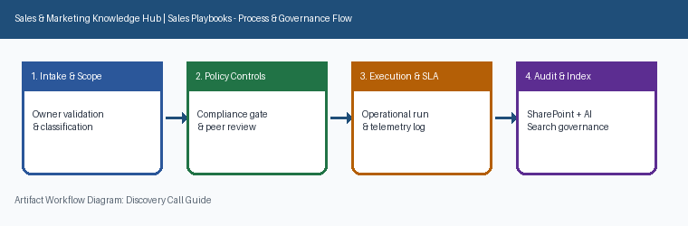
Page 2 of 6 | Sales & Marketing Knowledge Hub | Sales Playbooks | SharePoint Online

Section 3: Governance Standards & Controls
Structured guide for running a first discovery call, including qualifying questions and the handoff criteria into a technical evaluation. Section 3 (Governance Standards & Controls) applies to Sales Playbooks within Sales & Marketing Knowledge Hub and is maintained by Marcus Lee. Establishes mandatory compliance controls, approval thresholds, and audit evidence.
Operational requirement 3.1: Document discovery notes in the CRM within one business day of the call. Secondary control 3.2: Deals without a confirmed economic buyer by discovery end are flagged for coaching.
- Document discovery notes in the CRM within one business day of the call.
- Deals without a confirmed economic buyer by discovery end are flagged for coaching.
- Section 3 review cadence is tracked by Marcus Lee under Sales Playbooks governance.
Control Area | Owner | Target SLA | Verification Status
Sales Playbooks | Marcus Lee | 5 business days | Verified
Discovery Call Guide Gate 1 | Marcus Lee | 3 business days | Active
Discovery Call Guide Gate 2 | Marcus Lee | 10 business days | Monitored
Sec-3 | Marcus Lee | 10 business days | Stage 3 Verified
Page 3 of 6 | Sales & Marketing Knowledge Hub | Sales Playbooks | SharePoint Online

Section 4: Operational KPIs & Benchmarks
Structured guide for running a first discovery call, including qualifying questions and the handoff criteria into a technical evaluation. Section 4 (Operational KPIs & Benchmarks) applies to Sales Playbooks within Sales & Marketing Knowledge Hub and is maintained by Marcus Lee. Tracks baseline performance, target SLAs, and quarterly benchmark progression.
Operational requirement 4.1: Deals without a confirmed economic buyer by discovery end are flagged for coaching. Secondary control 4.2: Open with business context before diving into current tooling or pain points.
- Deals without a confirmed economic buyer by discovery end are flagged for coaching.
- Open with business context before diving into current tooling or pain points.
- Section 4 review cadence is tracked by Marcus Lee under Sales Playbooks governance.
Control Area | Owner | Target SLA | Verification Status
Sales Playbooks | Marcus Lee | 5 business days | Verified
Discovery Call Guide Gate 1 | Marcus Lee | 3 business days | Active
Discovery Call Guide Gate 2 | Marcus Lee | 10 business days | Monitored
Sec-4 | Marcus Lee | 5 business days | Stage 4 Verified
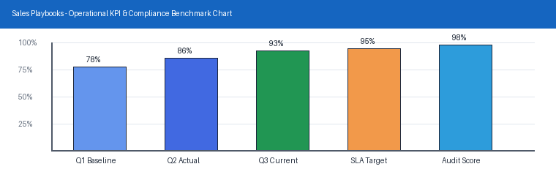
Page 4 of 6 | Sales & Marketing Knowledge Hub | Sales Playbooks | SharePoint Online

Section 5: Roles, Responsibilities & RACI
Structured guide for running a first discovery call, including qualifying questions and the handoff criteria into a technical evaluation. Section 5 (Roles, Responsibilities & RACI) applies to Sales Playbooks within Sales & Marketing Knowledge Hub and is maintained by Marcus Lee. Clarifies ownership across accountable executives, operational leads, and reviewers.
Operational requirement 5.1: Open with business context before diving into current tooling or pain points. Secondary control 5.2: Qualify budget, timeline, and decision process before scheduling a technical demo.
- Open with business context before diving into current tooling or pain points.
- Qualify budget, timeline, and decision process before scheduling a technical demo.
- Section 5 review cadence is tracked by Marcus Lee under Sales Playbooks governance.
Control Area | Owner | Target SLA | Verification Status
Sales Playbooks | Marcus Lee | 5 business days | Verified
Discovery Call Guide Gate 1 | Marcus Lee | 3 business days | Active
Discovery Call Guide Gate 2 | Marcus Lee | 10 business days | Monitored
Sec-5 | Marcus Lee | 3 business days | Stage 5 Verified
Page 5 of 6 | Sales & Marketing Knowledge Hub | Sales Playbooks | SharePoint Online

Section 6: Appendix, Lineage & Sign-off
Structured guide for running a first discovery call, including qualifying questions and the handoff criteria into a technical evaluation. Section 6 (Appendix, Lineage & Sign-off) applies to Sales Playbooks within Sales & Marketing Knowledge Hub and is maintained by Marcus Lee. Records document lineage, governance metadata, version history, and owner sign-off.
Operational requirement 6.1: Qualify budget, timeline, and decision process before scheduling a technical demo. Secondary control 6.2: Document discovery notes in the CRM within one business day of the call.
- Qualify budget, timeline, and decision process before scheduling a technical demo.
- Document discovery notes in the CRM within one business day of the call.
- Section 6 review cadence is tracked by Marcus Lee under Sales Playbooks governance.
Control Area | Owner | Target SLA | Verification Status
Sales Playbooks | Marcus Lee | 5 business days | Verified
Discovery Call Guide Gate 1 | Marcus Lee | 3 business days | Active
Discovery Call Guide Gate 2 | Marcus Lee | 10 business days | Monitored
Sec-6 | Marcus Lee | 10 business days | Stage 6 Verified
Page 6 of 6 | Sales & Marketing Knowledge Hub | Sales Playbooks | SharePoint Online

